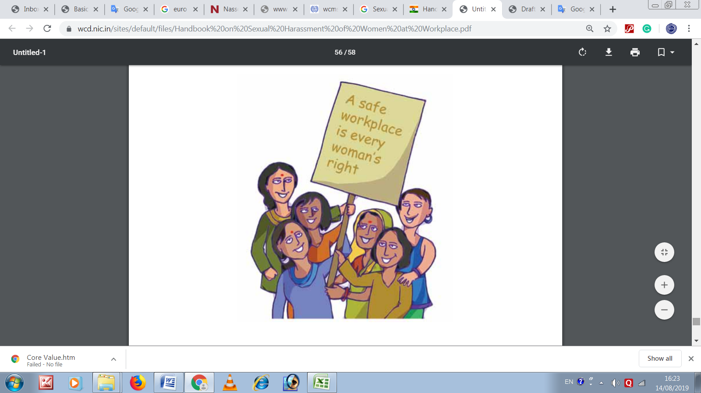

Contents

*Context* 3

**Chapter 1: Sexual Harassment at Workplace**

*1.1 Sexual Harassment at the Workplace* 4

*1.2 Examples of Behaviours and Scenarios That Constitue Sexual Harassment* 4

*1.3 Some examples of behaviour that may indicate underlying workplace sexual harassment and merit inquiry:* 5

*1.4 Forms of Workplace Sexual Harassment* 6

**Chapter 2: Prevention and Prohibition**

*2.1 Complaints Committee/s* 7

2.1.1 Internal Complaints Committee (ICC) 7

2.1.2 External Members on the Complaints Committee 7

*2.2 Dissemination of Information and Awareness Generation* 8

**Chapter 3: Redressal**

*3.1 Complainant and Place* 9

*3.2 Complaint’s Content* 9

*3.3 Ensured by Koshish* 10

*3.4 Rights of the Complainant* 10

*3.5 Rights of the Respondent* 10

*3.6 Key Responsibilities* 10

*3.7 Knowledge, Skills, Training* 11

*3.8 Non-Negotiable During the Inquiry Process* 11

*3.9 The Sexual Harassment Complaint Process* 11

3.9.1 STAGE ONE: RECEIPT OF THE COMPLAINT 12

3.9.2 STAGE TWO: PLANNING CAREFULLY 13

3.9.3 STAGE THREE: INTERVIEWS 14

3.9.4 STAGE FOUR: REASONING 15

3.9.5 STAGE FIVE: FINDING AND RECOMMENDATION 15

3.9.6 STAGE SIX: REPORT 16

*3.10 Timelines as per the Act* 17

*3.11 Confidentiality* 17

**Chapter 4: Monitoring**

*4.1 Inspection* 18

*4.2 Annual Report* 18

*4.3 Penalties* 18

# *Context*

Koshish Charitable Trust works with a vision to create and ensure an enabling environment for, every employee to work with dignity. For this, Koshish motivates all employees to work together without any fear of exploitation, harassment and violence. In this context, sexual harassment is form of physical and mental exploitation that should be prevented at any cost.

According to the Sexual Harassment at Workplace (Prevention, Prohibition and Redressal) 2013 is an act of power, and a public violation of a woman’s dignity that is often trivialized by labeling it an interpersonal transgression. The Sexual Harassment of Women at Workplace (Prevention, Prohibition & Redressal) Act, 2013 (hereinafter referred to as The Act) is in lines with the Vishakha Judgement by the Hon’ble Supreme Court of India has laid out that it is the duty of the employer or other responsible persons at work places or other institutions to prevent or deter the commission of acts of sexual harassment and to provide the procedure for the resolution, settlement or prosecution of acts of sexual harassment by taking all steps required.

According to the Protection of Human Right Act, 1993 "human rights" means the rights relating to life, liberty, equality and dignity of the individual guaranteed by the Constitution or embodied in the International Covenants and enforceable by courts in India. It is necessary and expedient for employers in work places as well as other responsible persons or institutions to observe certain guidelines to ensure the prevention of sexual harassment of women so as to live with dignity which is a fundamental right guaranteed by our constitution. Sexual harassment is contrary to anti discrimination law (Article 15: “prohibition of discrimination on grounds of religion, race, caste, sex or place of birth” and Article 19(1) (g) Right to freedom) which upholds a woman’s right “to practice any profession, or to carry on any occupation, trade or business.

Koshish, as per the provisions of the Saxual Harassment Act at Workplace, strives to put in place adequate system for safety, security, dignity of women.

**SEXUAL HARASSMENT AT WORKPLACE**

# *1.1 Sexual Harassment at the Workplace*

“Sexual Harassment” includes anyone or more of the following unwelcome acts or behaviour (whether directly or by implication), namely:

1. Physical contact or advances;

2. A demand or request for sexual favours;

3. Making sexually coloured remarks;

4. Showing pornography;

5. Any other unwelcome physical, verbal or non-verbal conduct of a sexual nature

# *1.2 Examples of Behaviours and Scenarios That Constitue Sexual Harassment*

Below are examples of behaviour that may or may not constitute workplace sexual harassment in isolation. At the same time, it is important to remember that more often than not, such behaviour occurs in cluster. Distinguishing between these different possibilities is not an easy task and requires essential training and skill building. Some examples of behaviour that constitute sexual harassment at the workplace:

1. Making sexually suggestive remarks or innuendos.
2. Serious or repeated offensive remarks, such as teasing related to a person’s body or appearance.
3. Offensive comments or jokes.
4. Inappropriate questions, suggestions or remarks about a person’s sex life.
5. Displaying sexist or other offensive pictures, posters, mms, sms, whatsapp, or e-mails.
6. Intimidation, threats, blackmail around sexual favours.
7. Threats, intimidation or retaliation against an employee who speaks up about unwelcome behaviour with sexual overtones.
8. Unwelcome social invitations, with sexual overtones commonly understood as flirting.
9. Unwelcome sexual advances which may or may not be accompanied by promises or threats, explicit or implicit.
10. Physical contact such as touching or pinching.
11. Caressing, kissing or fondling someone against her will (could be considered assault).
12. Invasion of personal space (getting too close for no reason, brushing against or cornering someone).
13. Persistently asking someone out, despite being turned down.
14. Stalking an individual.
15. Abuse of authority or power to threaten a person’s job or undermine her performance against sexual favours.
16. Falsely accusing and undermining a person behind closed doors for sexual favours.
17. Controlling a person’s reputation by rumour-mongering about her private life.

# *1.3 Some examples of behaviour that may indicate underlying workplace sexual harassment and merit inquiry:*

1. Criticizing, insulting, blaming, reprimanding or condemning an employee in public.
2. Exclusion from group activities or assignments without a valid reason.
3. Statements damaging a person’s reputation or career.
4. Removing areas of responsibility, unjustifiably.
5. Inappropriately giving too little or too much work.
6. Constantly overruling authority without just cause.
7. Unjustifiably monitoring everything that is done.
8. Blaming an individual constantly for errors without just cause.
9. Repeatedly singling out an employee by assigning her with demeaning and belittling jobs that are not part of her regular duties.
10. Insults or humiliations, repeated attempts to exclude or isolate a person.
11. Systematically interfering with normal work conditions, sabotaging places or instruments of work.
12. Humiliating a person in front of colleagues, engaging in smear campaigns.
13. Arbitrarily taking disciplinary action against an employee.
14. Controlling the person by withholding resources (time, budget, autonomy, and training)

# *1.4 Forms of Workplace Sexual Harassment*

Generally workplace sexual harassment refers to two common forms of inappropriate behaviour:

**• Quid Pro Quo (literally ‘this for that’)**

- Implied or explicit promise of preferential/detrimental treatment in employment

- Implied or express threat about her present or future employment status

**• Hostile Work Environment**

- Creating a hostile, intimidating or an offensive work environment

- Humiliating treatment likely to affect her health or safety

**Prevention and Prohibition**

# *2.1 Complaints Committee/s*

The Act provides for two kinds of complaints mechanisms: Internal Complaints Committee (ICC) and Local Complaints Committee (LCC). All Complaints Committees must have 50 per cent representation of women. ICC or LCC members will hold their position not exceeding three years from the date of their nomination or appointment.

### 2.1.1 Internal Complaints Committee (ICC)

Every employer is obliged to constitute an ICC through a written order. The ICC will be composed of the following members:

|  |  |  |
| --- | --- | --- |
| **No** | **Member** | **Eligibility** |
| 1. | Chairperson | Women working at senior level as employee; if not available then nominated from other office/units/ department/ workplace of the same employer |
| 2. | 2 Members (minimum) | From amongst employees committed to the cause of women/ having legal knowledge/experience in social work |
| 3. | Member | From amongst NGO/associations committed to the cause of women or a person familiar with the issue of Sexual Harassment |

### 2.1.2 External Members on the Complaints Committee

The Act refers to external members, which generally means persons who have expertise with the issue of sexual harassment. Given the largely intangible nature of workplace sexual harassment, there are a range of complexities involved in responding effectively to workplace sexual harassment complaints. For this reason, external third party/ members on the Complaints Committee/s (from civil society or legal background) should possess the following attributes:

1. Demonstrated knowledge, skill and capacity in dealing with workplace sexual harassment issues/complaints;
2. Sound grasp and practice of the legal aspects/implications.

Such expertise will greatly benefit Complaints Committees in terms of fair and informed handling of complaints to lead to sound outcomes. These external third party members shall be paid for their services on the Complaints Committees as prescribed.

# *2.2 Dissemination of Information and Awareness Generation*

**Koshish is legally responsible to:**

1. Effectively communicate a policy that prohibits unwelcome behaviour that constitutes workplace sexual harassment, and provides a detailed framework for prevention, and redress processes.
2. Carry out awareness and orientation for all employees.
3. Create forums for dialogue i.e. Panchayati Raj Institutions, Gram Sabhas, Women’s Groups, Urban Local Bodies or like bodies, as appropriate.
4. Ensure capacity and skill building of Complaints Committees.
5. Widely publicize names and contact details of Complaints Committee members.

**PROCESS OF REDRESSAL**

# *3.1 Complainant and Place*

# *3.2 Complaint’s Content*

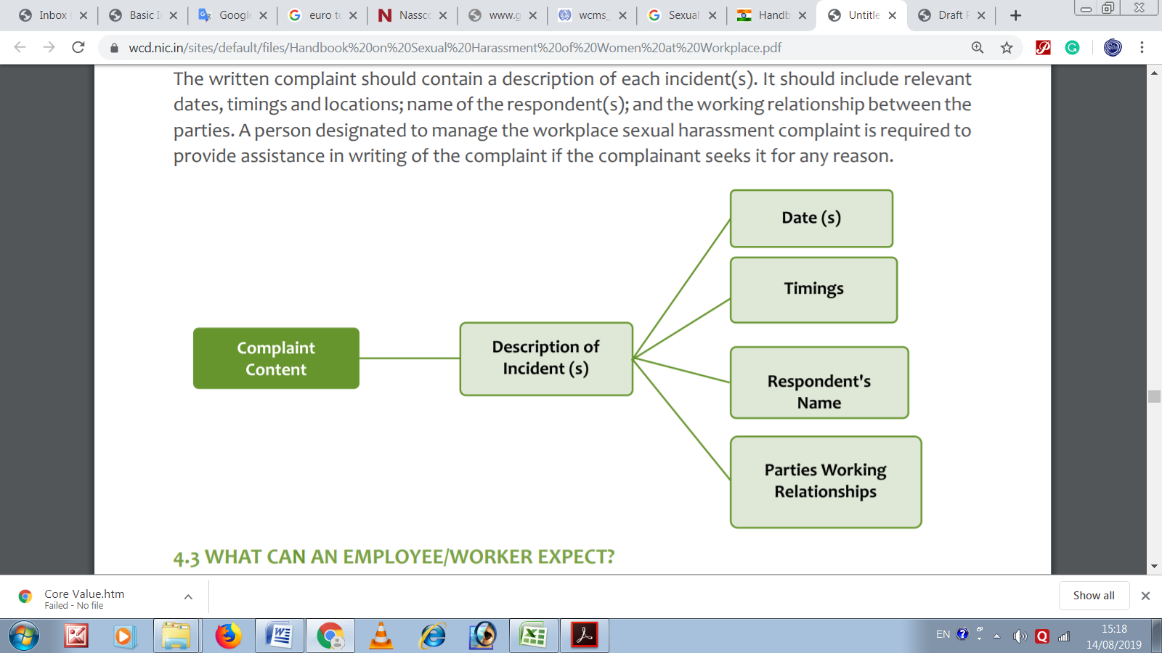The written complaint should contain a description of each incident(s). It should include relevant dates, timings and locations; name of the respondent(s); and the working relationship between the parties. A person designated to manage the workplace sexual harassment complaint is required to provide assistance in writing of the complaint if the complainant seeks it for any reason.

# *3.3 Ensured by Koshish*

When it comes to redress for workplace sexual harassment, employee/worker has a right to expect -a trained, skilled and competent Complaints Committee, a time bound process, information confidentiality, assurance of non-retaliation, counselling or other enabling support where needed and assistance if the complainant opts for criminal proceedings.

# *3.4 Rights of the Complainant*

* + An empathetic attitude from the Complaints Committee so that she can state her grievance in a fearless environment
  + A copy of the statement along with all the evidence and a list of witnesses submitted by the respondent
  + Keeping her identity confidential throughout the process
  + Support, in lodging FIR in case she chooses to lodge criminal proceedings
  + In case of fear of intimidation from the respondent, her statement can be recorded in absence of the respondent
  + Right to appeal, in case, not satisfied with the recommendations/findings of the Complaints Committee

# *3.5 Rights of the Respondent*

* + A patient hearing to present his case in a non-biased manner
  + A copy of the statement along with all the evidence and a list of witnesses submitted by the complainant
  + Keeping his identity confidential throughout the process
  + Right to appeal in case not satisfied with the recommendations/findings of the Complaints committee

# *3.6 Key Responsibilities*

To effectively address workplace sexual harassment complaints, a Complaints Committees must first be aware of their key responsibilities, some of which are highlighted below:

1. Be thoroughly prepared
2. Know the Act, Policy and/or relevant Service Rules
3. Gather and record all relevant information
4. Determine the main issues in the complaint
5. Prepare relevant interview questions 6. Conduct necessary interviews
6. Ensure parties are made aware of the process and their rights/responsibilities within it
7. Analyse information gathered
8. Prepare the report with findings/recommendations

# *3.7 Knowledge, Skills, Training*

Dealing with workplace sexual harassment complaints is often complex. Hence Complaints Committee/s must possess critical skills/capacity to effectively carry out their role. That includes a sound grasp of the Act, Vishaka Guidelines, applicable Service Rules, relevant laws and an understanding of workplace sexual harassment and related issues. Complaints Committee skills must include an ability to synthesise information i.e. relevant documents, the law and interviews. They should also be able to communicate effectively, write clearly, listen actively and conduct interviews. They should be competent at showing empathy, being impartial and being thorough. They should be able to identify sexual harassment and its impact.

A Complaints Committee/s is required to be trained in both skill and capacity to carry out a fair and informed inquiry into a complaint of workplace sexual harassment. An absence of such training will lead to unequal and unfair results, which can cost employers, employees, complainants as well as respondents.

# *3.8 Non-Negotiable During the Inquiry Process*

During a redress process the Complaints Committee/s are required to assure confidentiality, non retaliation and recommend interim measures as needed to conduct a fair inquiry.

# *3.9 The Sexual Harassment Complaint Process*

The Complaints Committee/s needs to have information on the six stages (including fifteen steps), detailed below, for addressing a complaint of workplace sexual harassment.

### 3.9.1 STAGE ONE: RECEIPT OF THE COMPLAINT

A fair, prompt, and impartial inquiry process starts with a Complaints Committee capable of creating an environment of trust and confidence throughout the inquiry.

**Step 1 :** Receive and Acknowledge Receipt of the Complaint

The complainant submits a sexual harassment complaint in writing within three months of the last alleged incident to the Complaints Committee or any other person designated by the organization/ District Officer (i.e. Nodal Officer) to receive and manage complaints of sexual harassment.

Upon receipt, the complaint should be reviewed for:

1. In the context of workplace that the sexual harassment complaint is to be met with under the Act, such as, Service Rules, Workplace Policy, Vishaka Guidelines and related laws.
2. Clarity in the complaint.
3. Additional information needed from the complainant. The complainant will be notified in writing to acknowledge receipt.

**Step 2:** Meet and Talk to the Complainant to Explore Options for Formal and Informal Resolution

The complainant needs to be informed about the ensuing process and the informal or formal options available for the redress.

**Step 3:** Informal Mechanism

If the complainant chooses to adopt the informal process to resolve her complaint/experience of workplace sexual harassment, then it is the responsibility of the person designated to receive and manage the Complaints Committee to explore enabling ways to address the complaint. This can include counselling, educating, orienting, or warning the respondent to promptly stop the unwelcome behaviour or appointing a neutral person to act as a conciliator between the parties to resolve the complaint through conciliation.

However, before recommending conciliation, the Committee must assess the severity of the situation and if necessary, advise and enable the complainant to opt for the formal route. At no point, the Complaints Committee will advise the complainant to resolve the matter directly with the respondent. Where such an informal process is successful, such resolution is to be recorded by the conciliator and forwarded to the ICC/LCC who in turn will forward the same to the employer/District Officer for further action based on the resolution. Employers/District Officers are responsible for taking steps to ensure that the complainant is not subject to any backlash.

The choice of a formal process rests with the complainant even if the person responsible for managing the complaint believes that this can be resolved through an informal process.

**Step 4:** Formal Mechanism

1. If the complainant opts for formal redress, or the nature of the complaint is serious which calls for formal redress, then the Complaints Committee responds to the complaint.
2. Complaints Committee/s members must be free of any conflict of interest with either the concerned parties or with the outcome.
3. Ensure that the independent third party member has sound knowledge, skill, and experience in dealing with workplace sexual harassment complaints.

**Step 5:** Respondent and Response

1. As per the procedure provided in the Service Rule; or in absence of the same
2. Within seven days of receiving a complaint, the Complaints Committee will inform the respondent in writing that a complaint has been received.
3. The respondent will have an opportunity to respond to the complaint in writing within ten days thereafter.

### 3.9.2 STAGE TWO: PLANNING CAREFULLY

**Step 6:** Prepare the File

A sound inquiry relies on sound preparation. This includes taking into account the following steps:

**1. Documentation**

Create an independent confidential file of the complaint and all subsequent related documentation.

**2. Review Law & Policy**

Have a clear knowledge and understanding of the Act/Rules as well as the relevant Service Rules, Workplace Policy, Vishaka Guidelines, existing practices and related laws.

**3. Make a List**

Make a list of all the dates and events relating to the written complaint as well as the names of witnesses, where applicable.

**4. Supporting Documents**

Obtain and review all supporting documents relevant to the complaint, including those presented by the complainant and the respondent.

**5. Act Quickly Create a plan.**

This can be used as an initial checklist to ensure that all of the critical elements are covered. It includes:

a. The names of the parties and witnesses to be interviewed

b. Any documentary support that needs to be examined

c. Timeline

**Step 7:** Consideration

**1. Interim Measures**

While a complaint is pending inquiry, a complainant can make a written request for her transfer or the transfer of the respondent, or for leave (upto 3 months). She can also request the Complaints Committee to restrain the respondent from reporting on her work performance or writing her confidential report or supervising her academic activities (in case she is in educational institution). Even in the absence of such a request, the Complaints Committee must take corrective action. It is essential to take these actions in order to prevent potential ongoing sexual harassment.

**2. Support**

Maintain clear, timely communication with the parties throughout the process. Provide complainants with any specific assistance they may require, such as counselling, addressing health related concerns or sanctioning of leave.

### 3.9.3 STAGE THREE: INTERVIEWS

**Step 8:** Prepare an Interview Plan for the Hearing: Complainant, Witnesses, Respondent

1. Based on the results of the previous steps and before conducting interviews, the Complaints Committee should decide which issues need to be pursued for questioning.
2. Interviews are meant to obtain information that is relevant to the complaint from individuals.
3. Interviews should be conducted with each person separately and in confidence. The complainant and the respondent should not be brought face to face with each other.

**Step 9:** Assess the Completeness of the Information Collected

At this stage, the Complaints Committee should review the information gathered and their factual relevance to each aspect of the complaint. This will help determine whether there is enough information to make a finding on the complaint.

### 3.9.4 STAGE FOUR: REASONING

**Step 10:** Once the information and review is complete, the Complaints Committee will make its reasoned finding(s), which involves having to:-

* + Identify the substance of each aspect of the complaint.
  + Determine, whether or not, on a balance of probability, the unwelcome sexual harassment took place.
  + Check that such behaviour/conduct falls within the definition of sexual harassment set out in the relevant Act/Rules, Policy, Service Rules or law.
  + Comment on any underlying factor(s) that may have contributed to the incident.

**Step 11:** Create a timeline to help establish the sequence of events related to the complaint.

**Step 12:** Compare similarities and differences within each of the statements made by the interviewees.

### 3.9.5 STAGE FIVE: FINDING AND RECOMMENDATION

**Step 13: Finding**

Based on the above, the Complaints Committee must arrive at a finding of whether the complaint is upheld, not upheld or inconclusive. Provided, where both the parties are employees, before finalising the findings, the ICC/LCC shall share its finding with both the parties and provide them an opportunity to make representation against it before the Committee.

**Step 14: Recommendations**

Based on its findings, the Complaints Committee shall then make appropriate recommendations which may include:

1. Where the Complaints Committee is unable to uphold the complaint, it shall recommend no action.
2. Where the Complaints Committee upholds the Complaint, it may recommend such action as stated within the relevant Policy or Service Rules, which may include a warning to terminate.

In case service rules do not exist, recommended action may include:

* + Disciplinary action, including a written apology, reprimand, warning, censure;
  + Withholding promotion/ pay raise/ increment;
  + Termination;
  + Counselling;
  + Community service.

3. The Complaints Committee may also recommend financial damages to the complainant, while deciding the amount they shall take into consideration:

* + Mental trauma, pain, suffering and emotional distress caused;
  + Medical expenses incurred;
  + Loss of career opportunity;
  + Income and financial status of the respondent.

If the amount is not paid it can be recovered as an arrear of land revenue.

4. The Complaints Committee can also give additional recommendations to address the underlying factors contributing to sexual harassment at the workplace.

### 3.9.6 STAGE SIX: REPORT

**Step 15: Writing the Report**

The Complaints Committee will prepare a final report that contains the following elements:

* + A description of the different aspects of the complaint;
  + A description of the process followed;
  + A description of the background information and documents that support or refute each aspect of the complaint;
  + An analysis of the information obtained;
  + Findings as stated above;
  + Recommendations.

An inquiry must be completed within 90 days and a final report submitted to the Employer or District Officer (as the case may be) within ten days thereafter. Such report will also be made available to the concerned parties. The Employer or District Officer is obliged to act on the recommendations within 60 days. Any person not satisfied with the findings or recommendations of the Complaints Committee or non-implementation of the recommendations, may appeal in an appropriate court or tribunal, as prescribed under the Service Rules or where no such service rules exist, in such manner as may be prescribed.

# *3.10 Timelines as per the Act*

|  |  |
| --- | --- |
| Submission of Complaint | Within 3 months of the last incident |
| Notice to the Respondent | Within 7 days of receiving copy of the complaint |
| Completion of Inquiry | Within 90 days |
| Submission of Report by ICC/LCC to employer/DO | Within 10 days of completion of the inquiry |
| Implementation of Recommendations | Within 60 days |
| Appeal | Within 90 days of the recommendations |

# *3.11 Confidentiality*

The Act prohibits the publication or making known the contents of a complaint and the inquiry proceedings. Any breach of confidentiality will result in specific consequences.

The Act prohibits the disclosure of:

* + Contents of the complaint;
  + Identity and address of complainant, respondent and witnesses; Information pertaining to conciliatory/inquiry proceedings or recommendations of the ICC/LCC;
  + Action taken by the employer/DO.

**MONITORING**

# *4.1 Inspection*

In relation to workplace sexual harassment, when it is in the public interest or in the interest of women employees, every employer/District Officer can be ordered by the Appropriate Government i.e. State and Central Government, to make available any information, record or document, including opening its workplace for inspection relating to the same.

# *4.2 Annual Report*

The Appropriate Government is entrusted with the monitoring of the implementation of this Act and for maintaining the data on the number of cases filed and disposed of under it. In particular, the Act mandates submission of an Annual Report by the ICC/LCC to the employer/District Officer.

The District Officer will forward a brief report on the annual reports to the appropriate State Government. Such reports must include the following information:

a. No. of complaints received;

b. No. of complaints disposed of;

c. No. of cases pending for more than 90 days;

d. No. of workshops/awareness programmes carried out;

e. Nature of action taken by the employer/DO;

The Report of ICC will be forwarded to the DO through the employer.

# *4.3 Penalties*

An employer can be subjected to a penalty of up to INR 50,000 for:

* + Failure to constitute Internal Complaints Committee
  + Failure to act upon recommendations of the Complaints Committee; or
  + Failure to file an annual report to the District Officer where required; or
  + Contravening or attempting to contravene or abetting contravention of the Act or Rules. Where an employer repeats a breach under the Act, they shall be subject to:
  + Twice the punishment or higher punishment if prescribed under any other law for the same offence.
  + Cancellation/ Withdrawal/ Non-renewal of registration/ license required for carrying on business or activities.

Monitoring is a critical yardstick to measure success in terms of compliance with the Act. Additionally, it highlights those areas, in terms of law and practice, which may require improvement and/or additional information and guidance at both the State as well as the workplace levels.